**Cloud Computing and AWS Fundamentals**

**Cloud** – The technology of distributed data processing in which some scalable information resources and capacities are provided as a service to multiple external customers through Internet technology.

**Cloud computing -**  is the on demand availability of computer system resources, especially data storage and computing power, without direct active management by the user. The term is generally used to describe data centers available to many users over the Internet.

**Based on Service Model, Architecture, and Flexibility**

**IaaS (Infrastructure as a Service)** – A computer infrastructure, typically presented in the form of virtualization.

**PaaS (Platform as a Service)** – An integrated platform for the development, deployment, testing and support of web-applications.

**SaaS (Software as a service)** – Is the business model of software license, which involves the development and support of the software vendor. Customers also have the opportunity of paid use of it, usually through the Internet.

**DaaS (Desktop as a Service)** – Another business model license the software, which is a slightly improved model of SaaS, mostly involving the use of multiple services at the same time necessary to complete the work. Was first introduced in the early 2000s.

In addition to the above within the concept of cloud hosting technology, there are also common notion Data as a service and Everything as a service respectively. Both concepts show that, through the World Wide Web using Cloud Hosting, can meet any requirements in the processing of information. This is the main advantage of cloud computing hosting in the IT-based business solutions.

**Cloud** – The technology of distributed data processing in which some scalable information resources and capacities are provided as a service to multiple external customers through Internet technology.

**Cloud computing basics concept includes all of the following concepts:**

**IaaS (Infrastructure as a Service)** – A computer infrastructure, typically presented in the form of virtualization. Is a service within the concept of cloud hosting.  
**PaaS (Platform as a Service)** – An integrated platform for the development, deployment, testing and support of web-applications. Presented as a service on the basis of the concept of **cloud hosting**.  
**SaaS (Software as a service)** – Is the business model of software license, which involves the development and support of the software vendor. Customers also have the opportunity of paid use of it, usually through the Internet.  
**DaaS (Desktop as a Service)** – Another business model license the software, which is a slightly improved model of SaaS, mostly involving the use of multiple services at the same time necessary to complete the work. Was first introduced in the early 2000s.

In addition to the above within the concept of cloud hosting technology, there are also common notion Data as a service and Everything as a service respectively. Both concepts show that, through the World Wide Web using Cloud Hosting, can meet any requirements in the processing of information. This is the main advantage of cloud computing hosting in the IT-based business solutions.

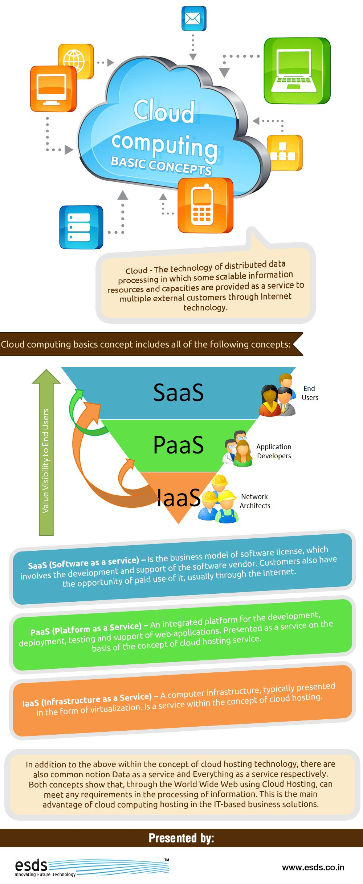

**Based on Infrastructure Ownership**

**Public Cloud**

Cloud most often means a public cloud. Most well-known and popular cloud services are public clouds. A public cloud basically offers services to any number of customers (the general public) and is accessible from the public information

**Private Cloud**

A private cloud uses the infrastructure to provide services only to a single customer. A private cloud is close related to virtualization, but provides many of the benefits of public clouds, such as elastic scaling and resource sharing.

**Virtual Private Cloud**

A virtual private cloud (VPC) is an isolated set of servers within a public cloud. Typically, the VPC would have a VPN connection to the enterprise network, and might logically seem to be part of the internal enterprise network.

**Community Cloud**

A community cloud extends the private cloud to incorporate multiple customers within a defined community (e.g., within an industry, such as health care or a cloud service serving diverse agencies and departments of the same government). This model is often preferred when the data is regulated and sensitive, and a degree of trust is required between the customers to accept the risks of cloud computing.

**Hybrid Cloud**

A hybrid cloud has characteristics of both a public cloud and a private cloud. For example, some resources could be offered to the public, while some are reserved for internal use.